**PROFILE**

### Creation On Profile

|  |  |
| --- | --- |
| TEAM ID | AD47707C5D4D5109D5E480002BDB30D50 |
| PROJECT TITTLE | Build an Event Management System using salesforce |

1. From Setup enter Profiles in the Quick Find box, and select Profiles. 

### 2. From the list of profiles, find Standard User.

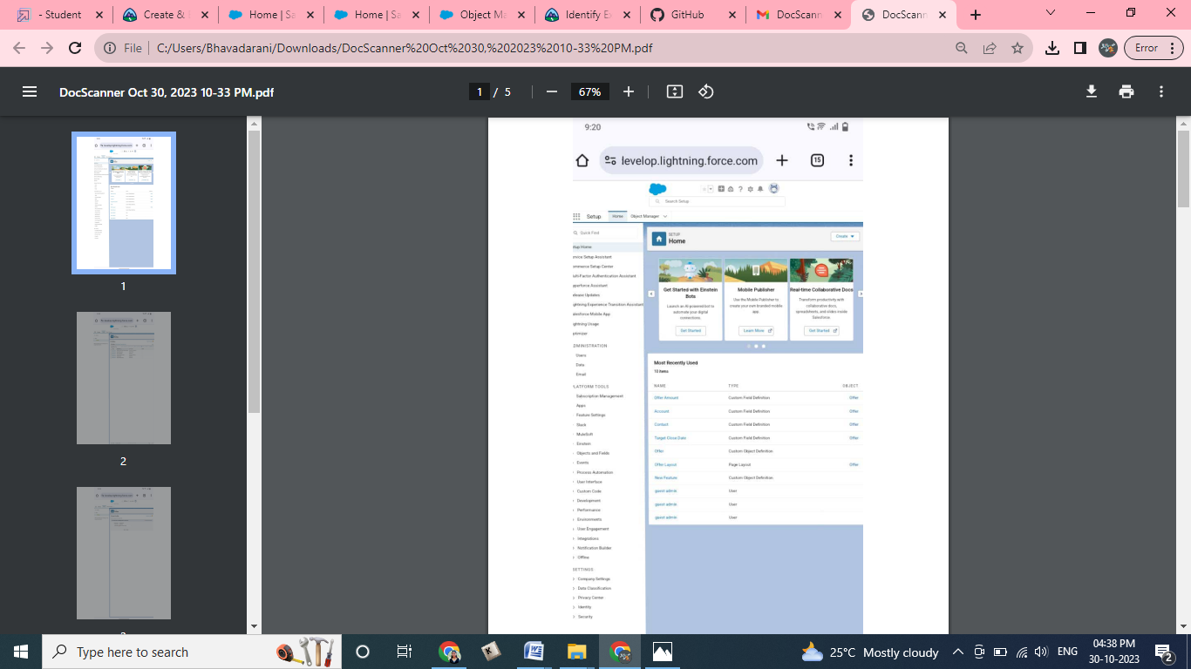

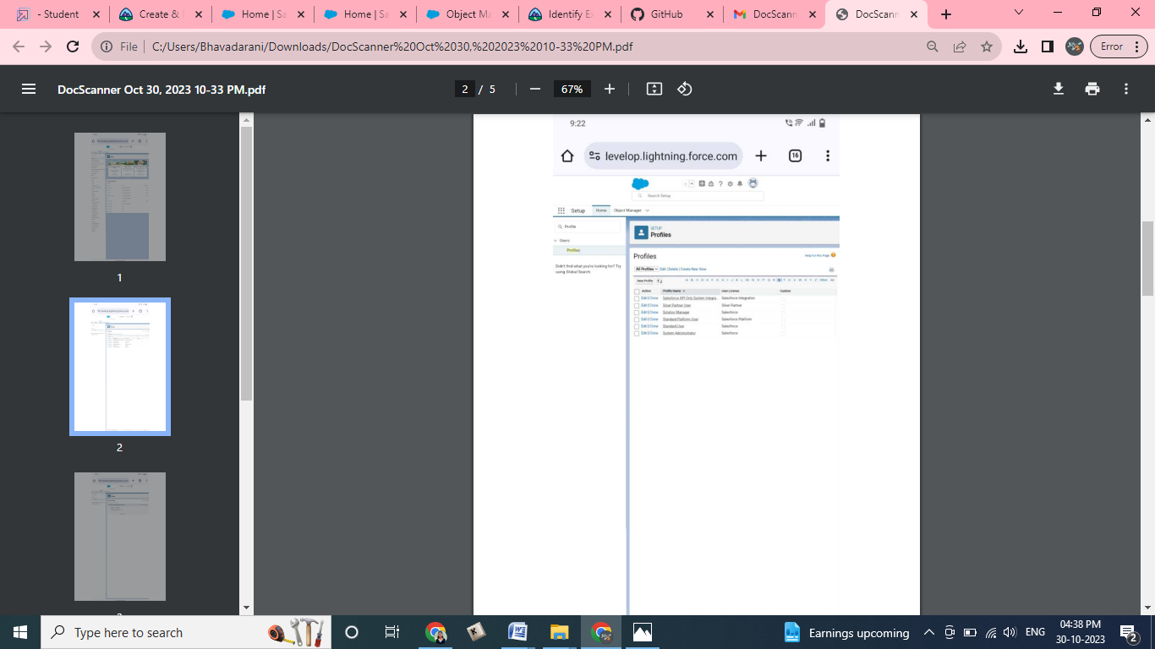

3. Click Clone.  
4. For Profile Name, enter Event user profile.   
5. Click **Save**. 

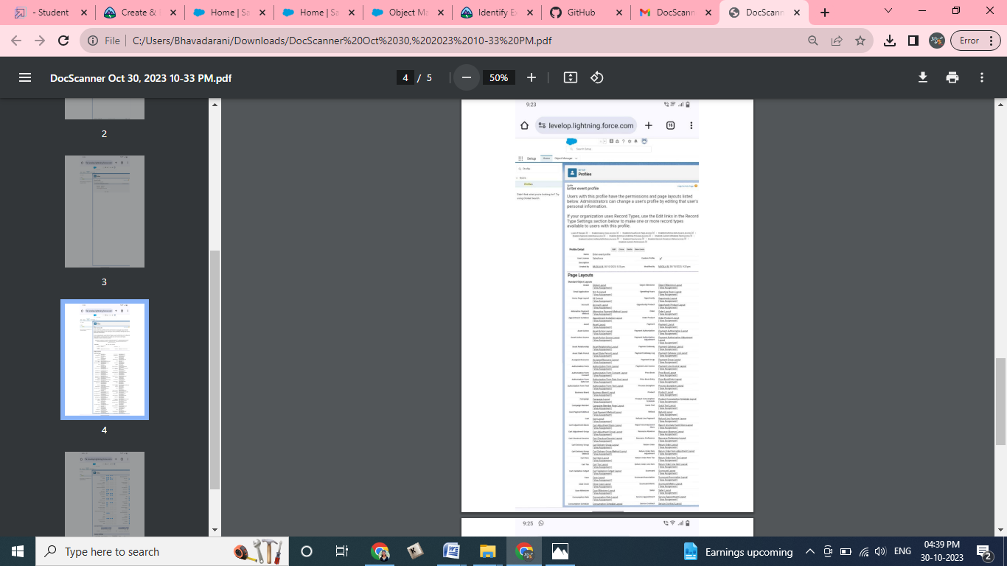

6. While still on the Event profile page, then click **Edit.**

7. Scroll down to Custom Object Permissions and Give view all access permissions to the Attendees, speakers and vendors.

